INTRODUCTION TO THE PROJECT

**Project Request:**

The **DENTAL CLINIC MANAGEMENT SYSTEM** has been developed to override the problems prevailing in the practicing manual system. This software is supported to eliminate and, in some cases, reduce the hardships faced by this existing system.

**Purpose:**

Dental clinic management software promotes easy data entry and usage. It includes patient’s personal information, dental history, and patient history. This makes your dental practice more convenient, efficient and precise.

**Objective of proposed system:**

The main objective of proposed system is to manage the details of dental clinic, doctors, patients and appointments. It manages all the information about dental clinic, booking, appointment, dental clinic. It tracks all the details about the patient, test, and appointment.

The purpose of project is to build an application program to reduce the manual work for managing the dental clinic, doctors, appointments & patients.

Project Profile

|  |  |
| --- | --- |
| **Full Name** | **RAJKUMAR GAURANGBHAI SHAHU** |
| **Project Title** | **Dental Clinic Management System** |
| **Roll No.** | **63** |
| **University Exam No.** |  |
| **Front End Tool** | **ASP.NET With C#** |
| **Back End Tool** | **SQL Server** |
| **Project Guide** | **Prof. Hemali Patel** |

Scope of Work

It may help collecting perfect management in details. In a very short time, the collecting will be obvious, simple and sensible.

It will help a person to know the management of passed year perfectly. It also helps in current all works relative to dental clinic management system. It will be also reducing the cost of collecting the management and collection procedure will go on smoothly.

The system generated types of information that can be used for various purpose:

• Utilize resources in an efficient manner by increasing their productivity.

• It satisfies the user requirement.

• Be easy to understand by the user and operator.

• Be easy to operate.

• Have a good user interface.

An Existing System

An existing system is based on manual work and all the process are done manually, so they maintain register and files for recording all to details of the system.

The existing system maintains all the records like patient informantion. They have to maintain a special register to maintain the patient details including their names, address and contect number etc.

The aim is to automate is existing manual system by the help of computerized eqiupment’s fulfilling their requirements, so that their valuable data can be stored for a longer period with easy accessing and manipulation of the same.

The old manual system was suffering from a series of drawbacks. Since whole of the system was to be maintained with hands the process of keeping, maintaining and retrieving the information was very tedious and lengthy. The records were never used to be in a systematic order.

There used to be lots of difficulties in associating any particular transaction with a particular context. If any information was to be found it was required to go through the different registers, documents there would never exist anything like reports generation. One more problem was that it was very difficult to find errors while entering the records. Once the records were entered it was very difficult to update these records.

The reason behind it is that there is lot of information to be maintained and have to be kept in mind while running the business.

The phase of system analysis process deals with problems which are affecting in the current manual system. The problems are those which are affecting the manual system in its daily routine work.

The problems faced by existing system are described as below: -

* Difficulty in maintenance of records.
* Time Consuming.
* No security of data.
* Lack of efficiency and man power.
* High data redundancy.
* Data inconsistency.

Need of Propose System

* System needs store information about new entry of dental clinic.
* System needs to help the internal staff to keep information of doctor and find them as per various queries.
* To maintain quantity records. To keep the record of patient.
* System needs to update and delete the record.
* Need a search area and also needs a security system to prevent data.

Feasibility Study

After doing the project dental clinic management system, study and analyzing all the existing or required functionalities of the system the next task is to do the feasibility study for the project.

The proposed solution satisfies all the user requirements and should be flexible enough so that future changes can be easily alone based on the future upcoming requirements.

* **Economical Feasibility:**

This is a very important aspect to be considered while developing project. We decided the technology based on minimum possible cost factor.

All hardware and software cost has to be borne by the organization. Overall, we have estimated that the benefits the organization is going to receive from the proposed system will surely overcome the initial costs and the later on running cost for system.

* **Technical Feasibility:**

This included the study of function performance and constraints that may affect the ability to achieve an acceptable system. For this feasibility study, we studied complete functionality to be provided in the system as described in the system requirement specification.

* **Operational Feasibility:**

No doubt the proposed system is fully GUI based that is very user friendly and all inputs to be taken all self-explanatory ever to a layman. Besides a proper training has been conducted to let know the essence of the system to the users so that they feel comfortable with new system. As far our study is concerned the clients are comfortable and happy as the system has cut down their loads and doing.

System Futures

* Product and Component based.
* Creating and changing issues at ease.
* Query issue list to any depth. Simple status and resolution.
* Multi-level priorities and severities. It contains better storage capacity. Accuracy in work.
* Easy and fast retrieval of information.
* Well-designed reports.
* Access of any information individually.
* Work becomes very speedy. Easy to update information.

Hardware and Software

* Minimum Hardware Specification for Developer :

|  |  |
| --- | --- |
| Processor | Intel(R)core(TM)2 Duo CPU @2.93 GHz |
| RAM | 2 GB |
| Storage | 10 GB |
| System Type | 32 - bit Operating System |

* Minimum Software Specification for Developer :

|  |  |
| --- | --- |
| Front-End Tool | ASP.Net With C# |
| Back-End Tool | SQL SERVER |
| Operating System | Window 7 |
| Web Browser | Any Web Browser |

* Minimum Hardware Specification for User :

|  |  |
| --- | --- |
| RAM | 2 GB |
| Storage | 10 GB |

* Minimum Software Specification for User :

|  |  |
| --- | --- |
| Operating System | Window 7 |
| Web Browser | Any Web Browser |

Data Flow Diagram [DFD]

I used data flow diagram to documents the system. DFDs document a system in a hierarchical manner and the diagram in figure represents the highest level. The diagram is called a context diagram because it represents the system in the context of its environment.

**DFD Elements:**

A DFD needs to be simple because a user has to go through it, understand it, and suggest correction or changes. A data flow diagram user only four elements.

* Process
* External entity
* Dataflow
* Data

**Store Symbol used in DFD:**

**1.Process:**

Here flow of data is transformed. A process represents some account of working behavior of data transformation of data from one from to another.

A circle represent a process

**2.External Entity:**

A source or destination of data which is external to the system. As the name suggest it lies outside the context of the outside the context of the system. It is represented by square.

**3.DataFlow:**

It is packet of data. It may be in the form of document, letter etc. A data flower presents the path of data it flows through the system. An arrow represented it.

The arrowed points in the direction in which the data moves. The name of the data flow is written slung the line..

**4.Data Store:**

Any store but with no references to the physical method to string. It there is a logical requirement for the data to be stored. It is help in adata store. It is represented by open ended rectangle. A number and a name identify each data store like a process.

* **Context Level DFD :**

Response

Response

**ADMIN**

**PATIENT**

Request for Registration

Request for Login

* **Zero Level DFD For Admin side.**

Response

Response

Response

Response

Response

Response

ADMIN

Response

Request for Login

Request for Manage Categories

Request for Manage Patients

Request for Manage Doctor

Request for Manage Appointment

Request for Manage Payment

Request for Manage History

Response

Response

ADMIN_TBL

DENTIST_TBL

APPOINT_TBL

SERVICES_TBL

PATIENTS_TBL

Response

Response

Response

Request

Request

Request

Request

Response

Response

Request

Request

Request

* **First Level DFD For Admin side (Process 2).**

ADMIN

SERVICE_TBL

Request for login

Request for add categories

Request for Update categories

Request for remove categories

Responseee

Responseee

Responseee

Responseee

Responseee

Responseee

Responseee

Responseee

Request

Request

Request

Request

* **First Level DFD For Admin side (Process 3).**

ADMIN

PATIENTS_TBL

Request for login

Request for view patient

Request for add new patient

Request for update patient

Response

Response

Response

Response

Response

Response

Response

Response

Request

Request

Request

Request

* **First Level DFD For Admin side (Process4).**

ADMIN

DENTIST_TBL

Request for login

Request for add doctor

Request for update details

Request for remove doctor

Response

Response

Response

Response

Response

Response

Response

Response

Request

Request

Request

Request

* **First Level DFD For Admin side (Process 5).**

ADMIN

APPOINT_TBL

Request for login

Request for view

Request for manage

Request for remove

Response

Response

Response

Response

Response

Response

Response

Response

Request

Request

Request

Request

* **First Level DFD For Admin side (Process 6).**

ADMIN

APPOINT_TBL

Request for login

Request for view

Request for update

Request for manage

Response

Response

Response

Response

Response

Response

Response

Response

Request

Request

Request

Request

* **First Level DFD For Admin side (Process 7).**

ADMIN

APPOINT_TBL

Request

Response

Response

Request

Request

Response

Response

Request for manage history

Request for view History

Request for login

Response

Response

* **Zero Level DFD For Patient Side.**

PATIENT

DENTIST_TBL

PATIENT_TBL

DENTIST_TBL

APPOINT_TBL

Request

Response

Request

Request

Request

Request

Request

Response

Response

Response

Response

Response

Response

Response

Response

Request

Response

Response

Response

Response

Request for view Doctor Details

Request for Registration

Request for Login

Request for view and Update Profile

Request for chose Doctor

Request for Book Appointment

Request for Payment

Response

* **First Level DFD For Patient side (Process 1).**

PATIENT

DENTIST_TBL

Request for view Doctor Details

Request for Search Doctor

Response

Response

Response

Response

Response

Response

* **First Level DFD For Patient side (Process 5).**

PATIENT

DENTIST_TBL

Request

Response

Response

Request

Request

Response

Response

Request for chose Doctor

Request for view Doctor details

Request for login

Response

Response

* **First Level DFD For Patient side (Process 6).**

PATIENT

APPOINT_TBL

Request for login

Request for chose doctor

Request for apointment

Request for payment

Response

Response

Response

Response

Response

Response

Response

Response

Request

Request

Request

Request

Database Layout

* ADMIN_TBL :-

|  |  |  |
| --- | --- | --- |
| **Field Name** | **Data Type** | **Constrain** |
| ADMIN_ID | int | Primary Key |
| ADMIN_NAME | Varchar(30) | Not Null |
| EMAIL-ID | Varchar(30) | Check |
| PASSWORD | Varchar(10) | Not Null |
| PHONE_NO | Numeric(10) | Not Null |

* DENTIST_TBL :-

|  |  |  |
| --- | --- | --- |
| **Field Name** | **Data Type** | **Constrain** |
| D_ID | int | Primary Key |
| D_NAME | varchar(20) | Not Null |
| DEGREE | varchar(10) | Not Null |

* PATIENT_TBL :-

|  |  |  |
| --- | --- | --- |
| **Field Name** | **Data Type** | **Constrain** |
| P_ID | int | Not Null |
| P_NAME | varchar(30) | Not Null |
| AGE | numeric(2) | Not Null |
| GENDER | varchar(10) | Not Null |
| PHONE_NO | numeric(10) | Not Null |
| EMAIL_ID | varchar(30) | Primary key |
| PASSWORD | varchar(10) | Not Null |
| ADDRESS | varchar(50) | Not Null |
| CITY | varchar(10) | Not Null |
| PINCODE | numeric(6) | Not Null |

* SERVICES_TBL :-

|  |  |  |
| --- | --- | --- |
| **Field Name** | **Data Type** | **Constrain** |
| ID | int | Primary Key |
| SERVICE_NAME | varchar(30) | Not Null |

* APPOINT_TBL :-

|  |  |  |
| --- | --- | --- |
| **Field Name** | **Data Type** | **Constrain** |
| A_ID | int | Primary Key |
| P_NAME | varchar(30) | Not Null |
| PHONE_NO | Numeric(10) | Not Null |
| EMAIL_ID | varchar(30) | Not Null |
| INSURANCE | varchar(10) | Not Null |
| D_NAME | varchar(20) | Not Null |
| SERVICES | varchar(20) | Not Null |
| A_DATE | varchar(10) | Check |
| A_TIME | varchar(10) | Check |
| CHARGE | Numeric(4) | Not Null |

Webpage View

Home Page view:

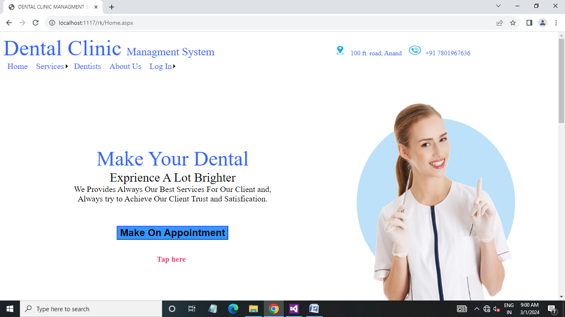

* This is home page where patient view all providing services, all dentists, about of clinic and login to book appointment.

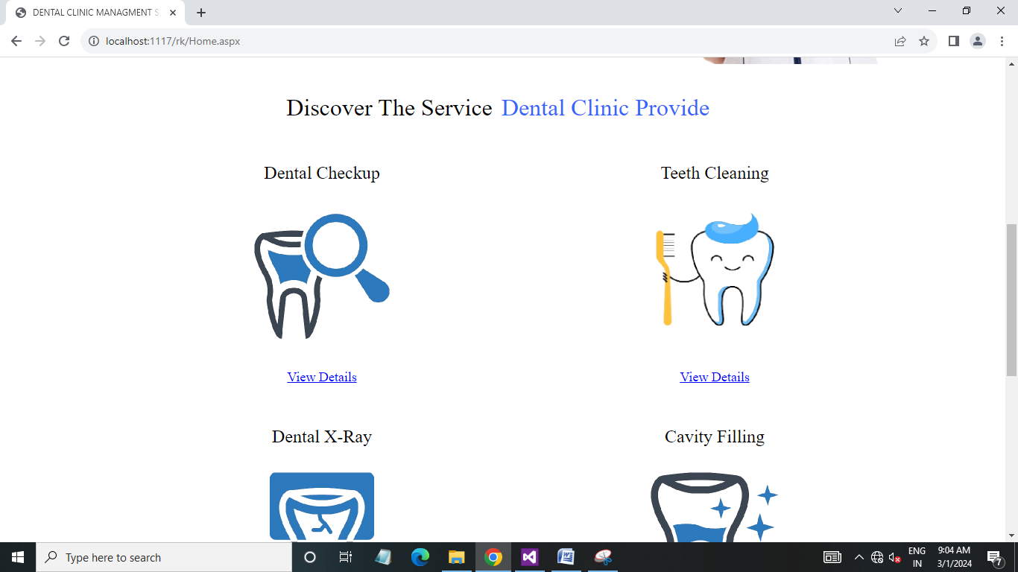

* In this page patient view all providing services and read all details about services.

Services pages :

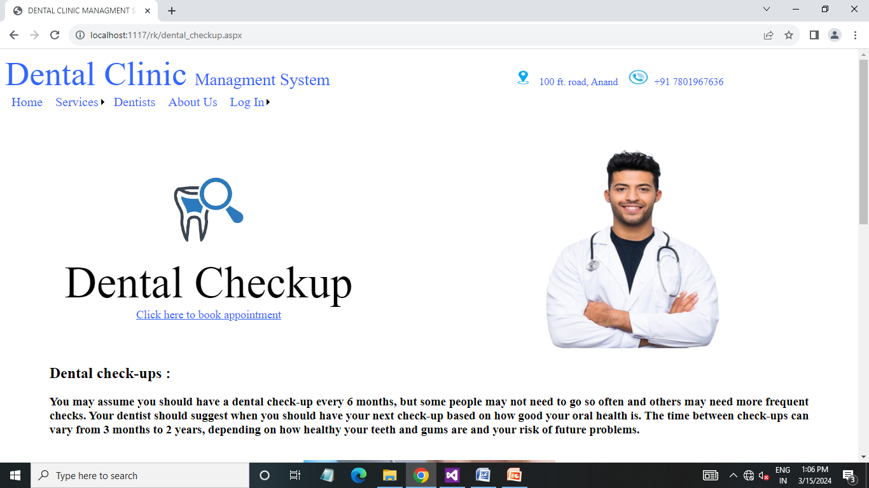

* In this page patient view and read all details of particular service.

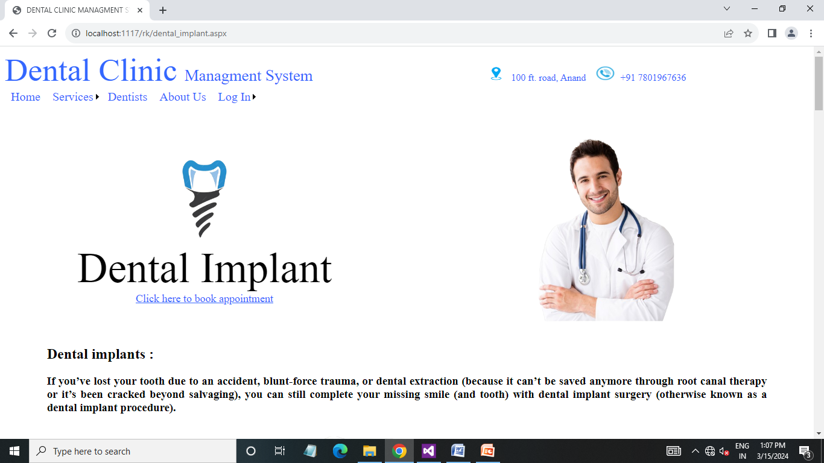

* In this page patient view and read all details of particular service.

About us Page :

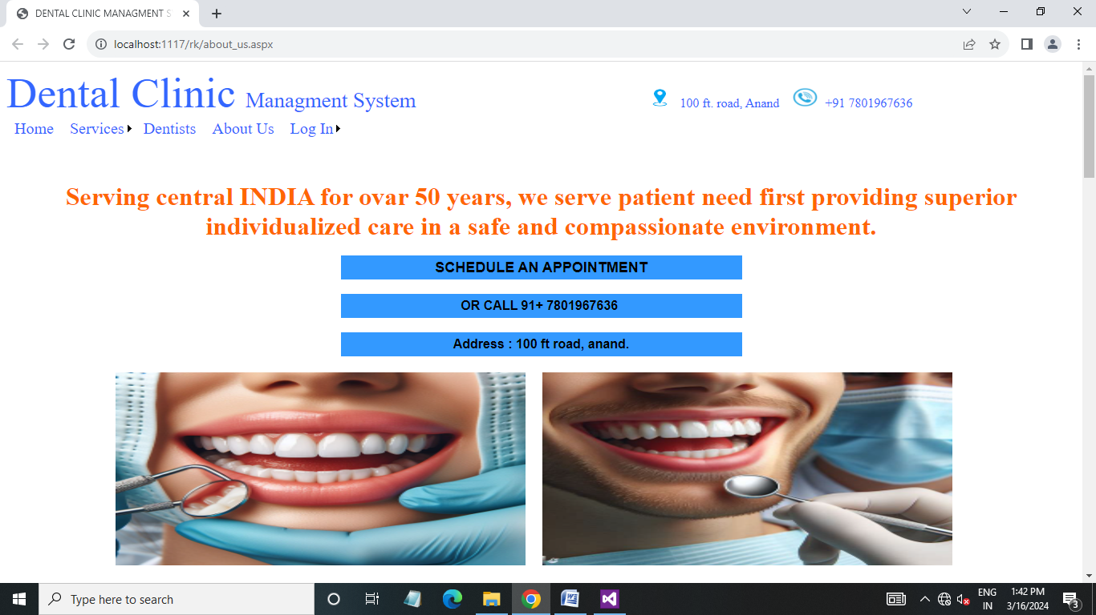

* In this page patient view all details about of dental clinic.

Login Page :

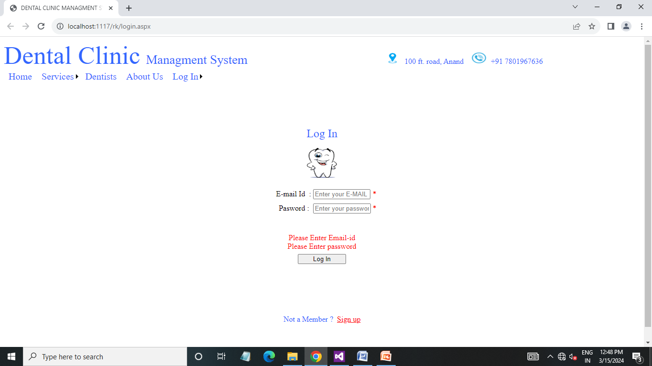

* This is login page and to patient login required proper valid email-id and password.

Registration Page :

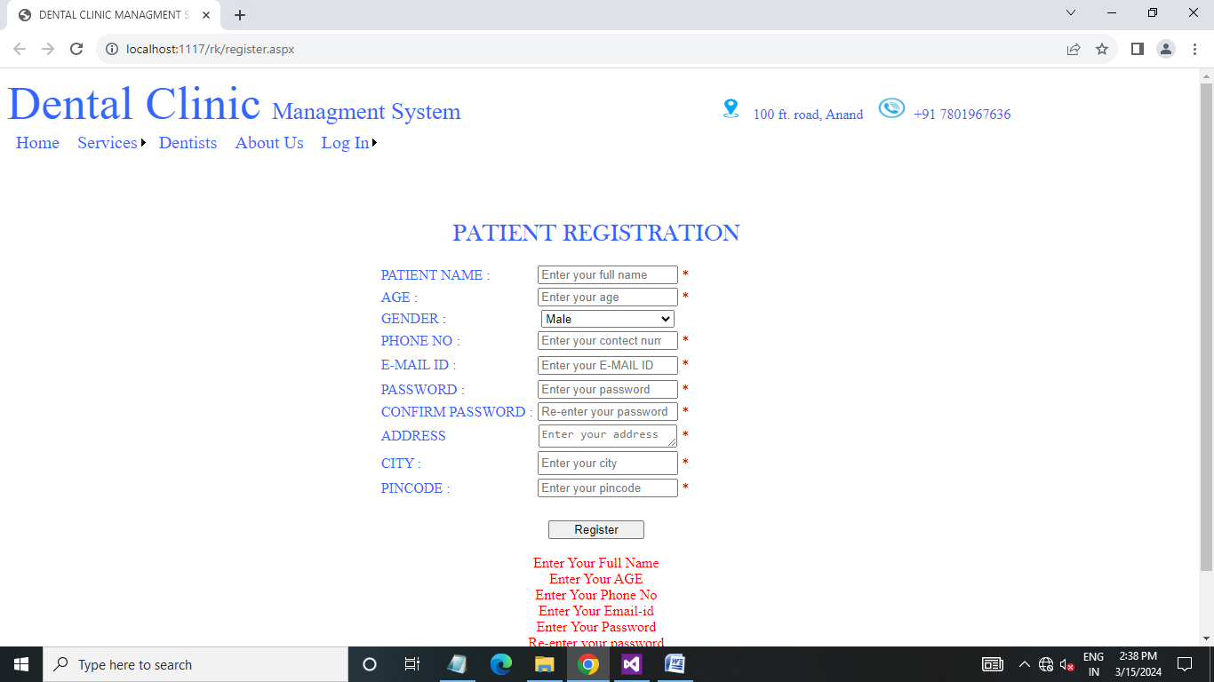

* This is registration page and to patient registration required proper all valid data.
* When patient insert a wrong data when data not inserted.

Registration Page :

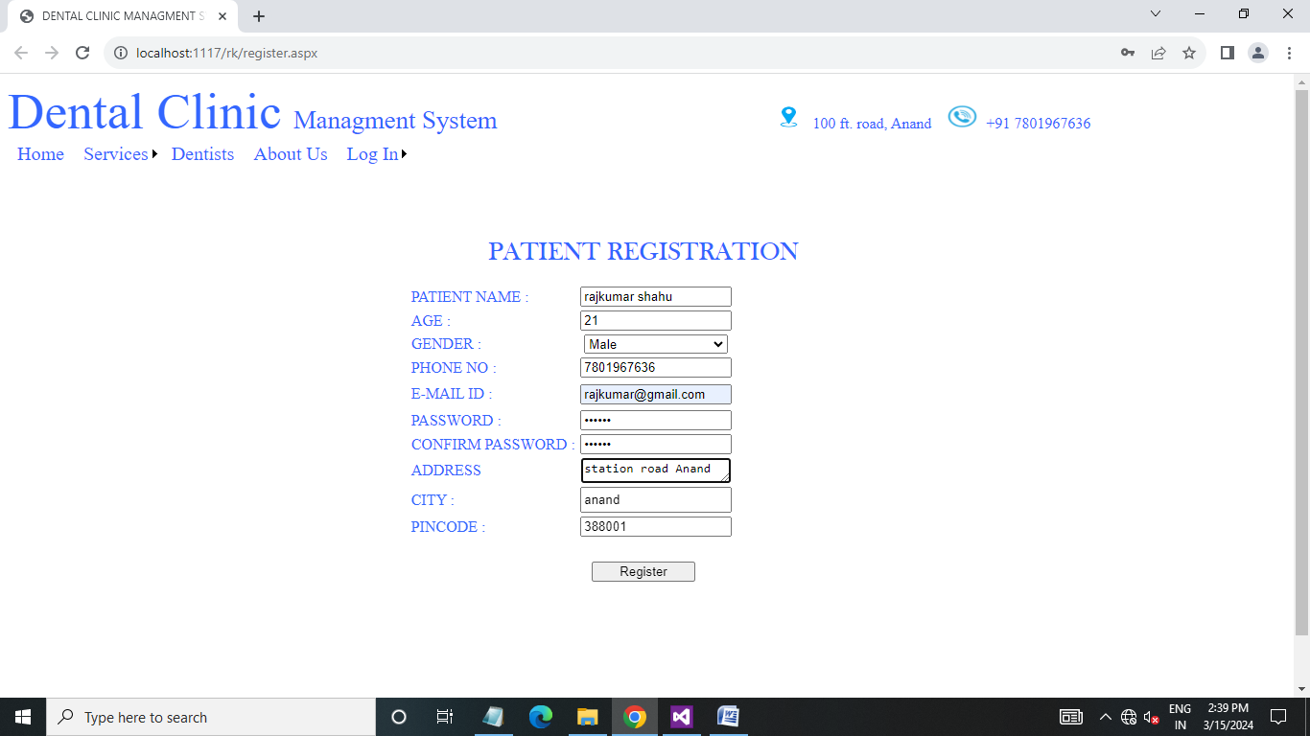

* This is example of fulfil proper data to registration.

Registration success Page :

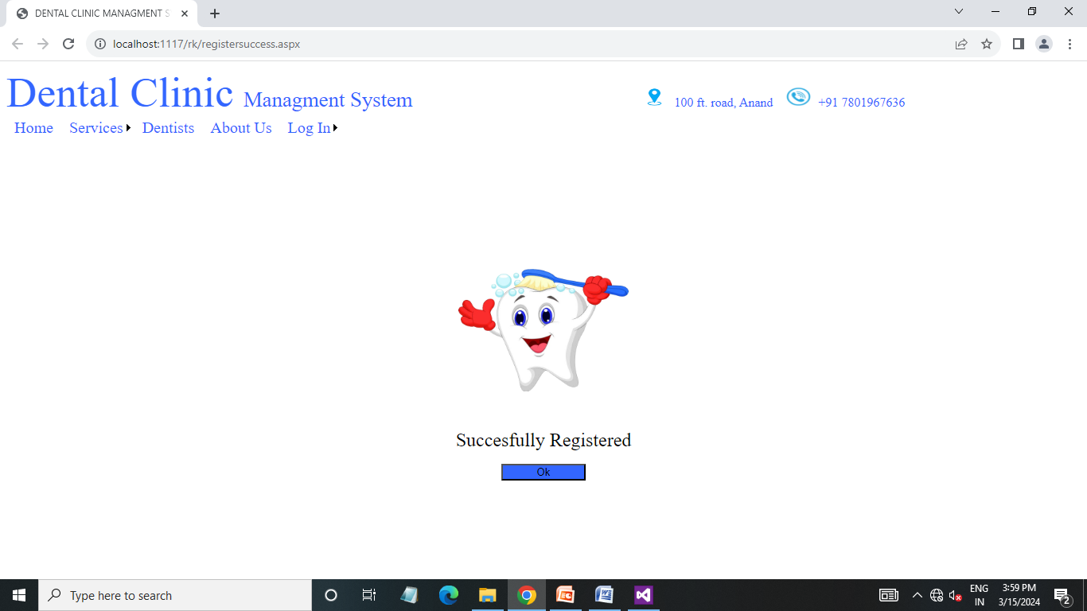

* This is registration success page.

Registration Page :

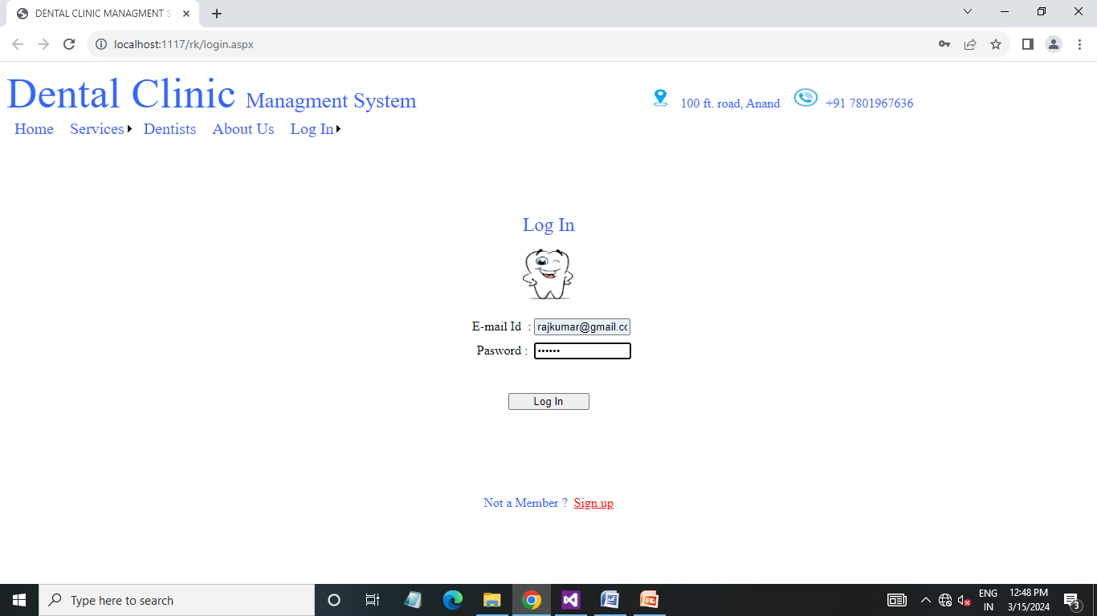

* This is login page and to patient login required proper valid email-id and password.

Login success Page :

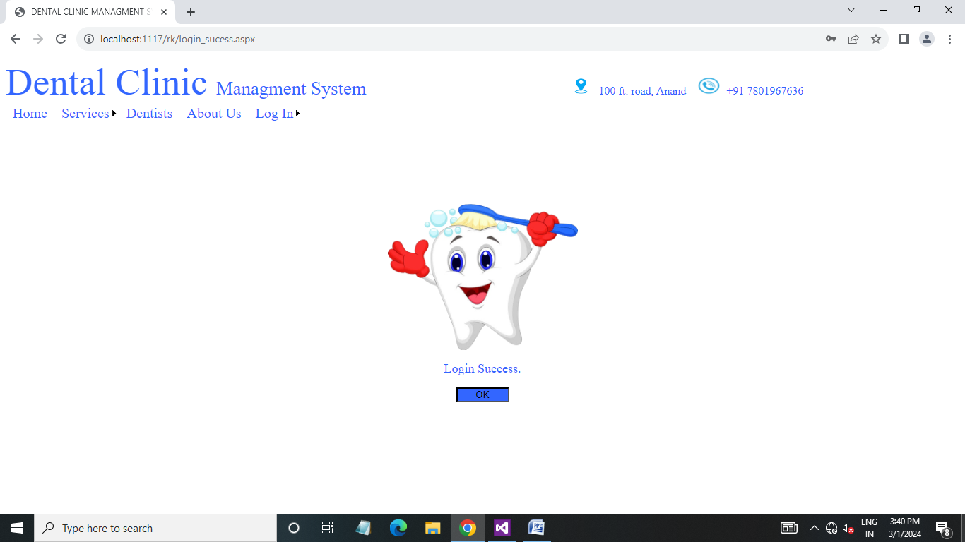

* This is log-in success page.

Book appointment page :

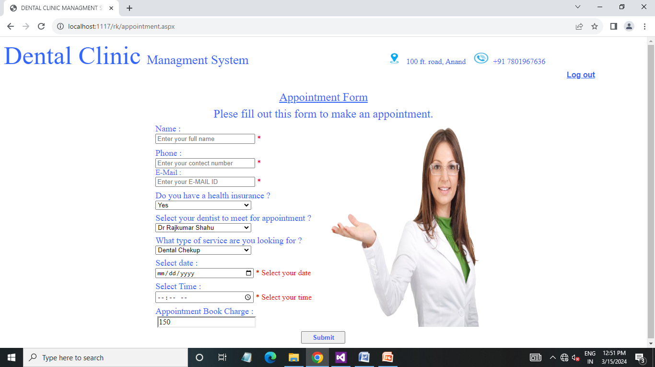

* This is book appointment page and to patient registration required proper all valid data.
* When patient insert a wrong data when data not inserted.

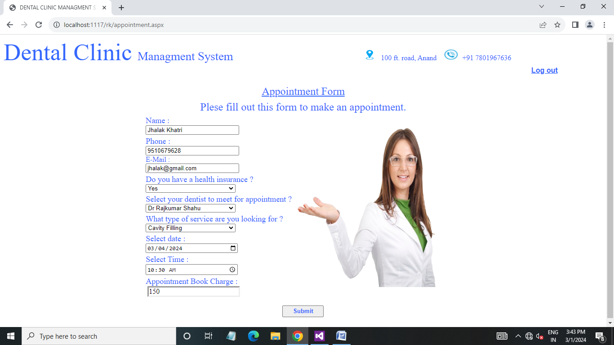

* This is example of fulfil proper data to book appointment.

Appointment success page :

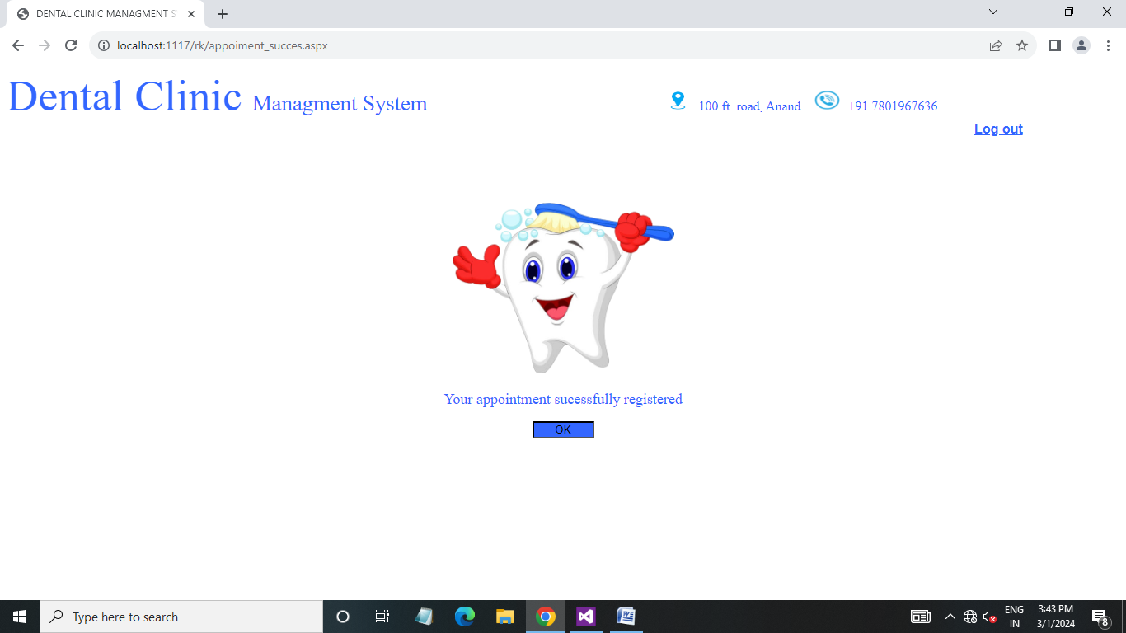

* This is appointment success page.

View booked appointment page :

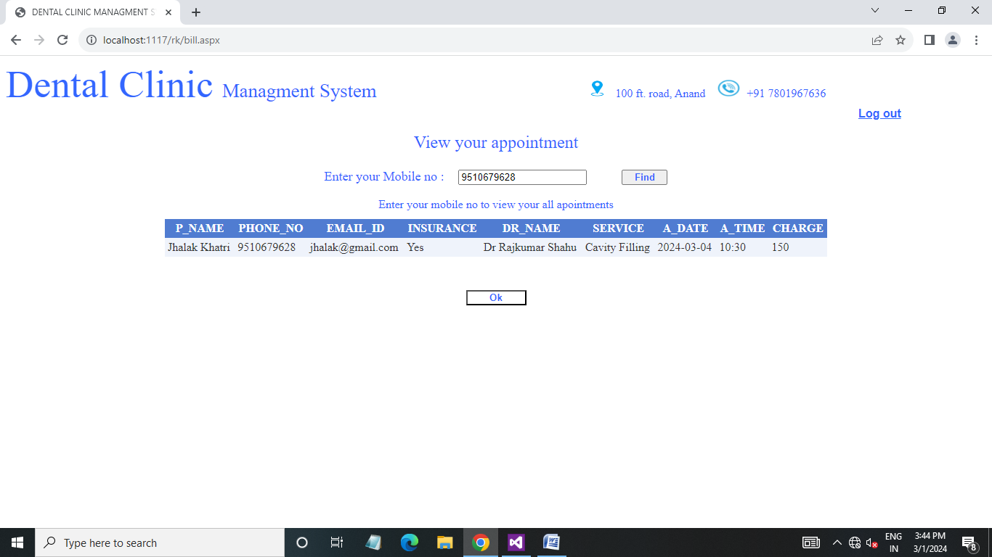

* In this page patient view own all booked appointment when patient insert own mobile number.

Admin login page :

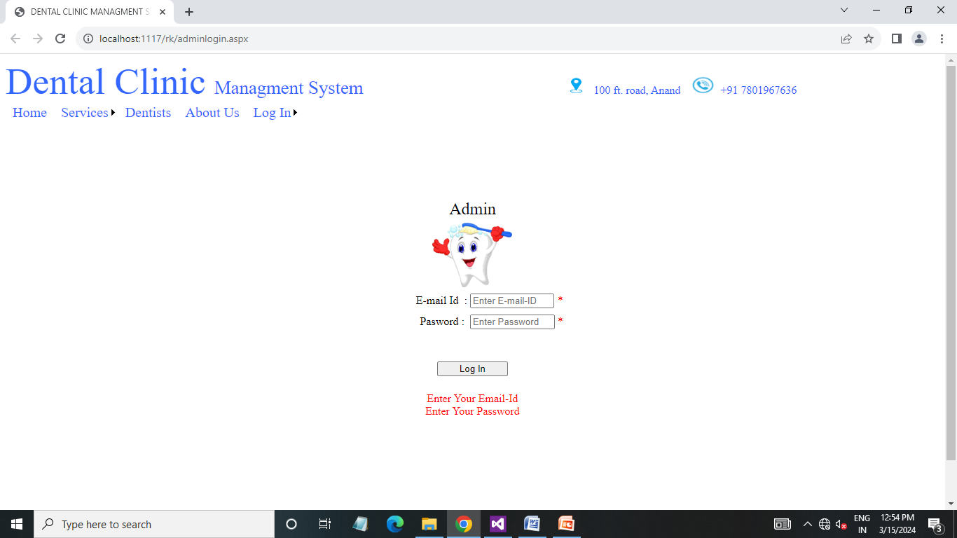

* This is admin login page and to admin login required proper valid email-id and password.

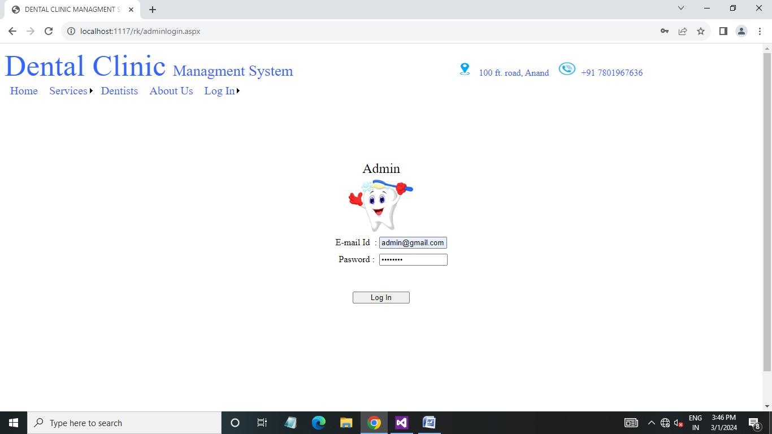

* This is example of fulfil proper data to login.

Admin home page :

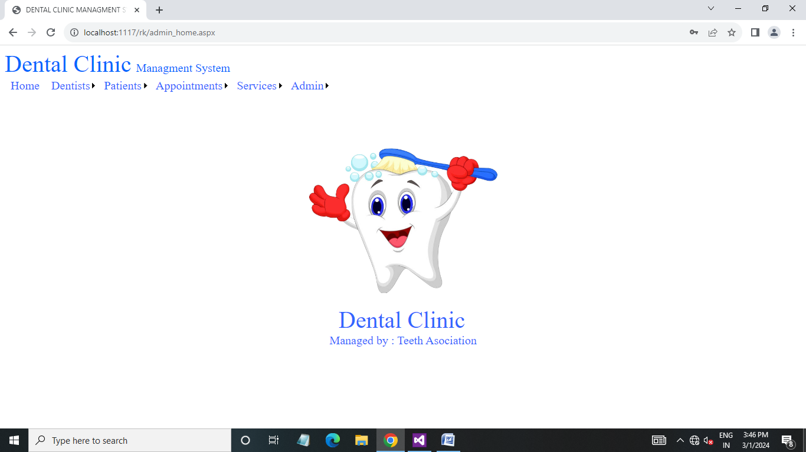

* This is admin home page.

Admin side dentist list page :

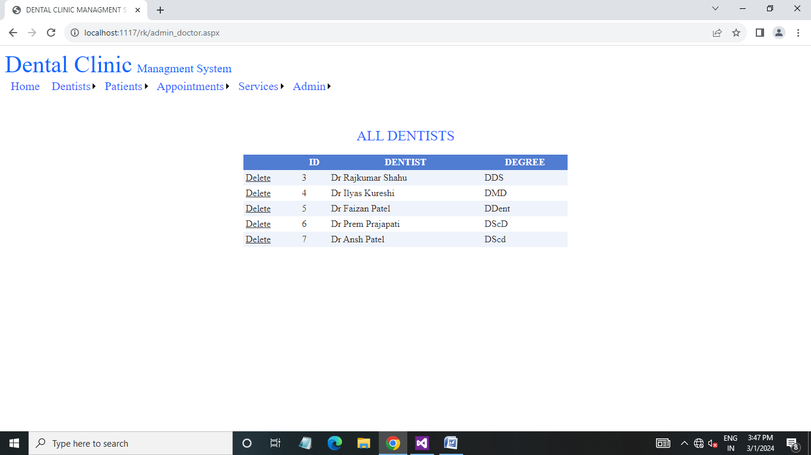

* In this page admin view all clinic dentist and admin also delete dentist.

Admin side add dentist page :

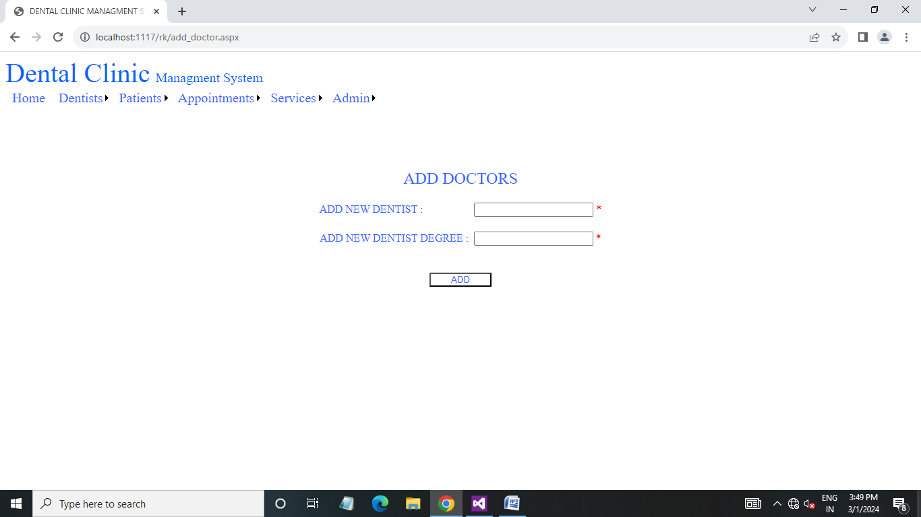

* In this page admin add new dentist.

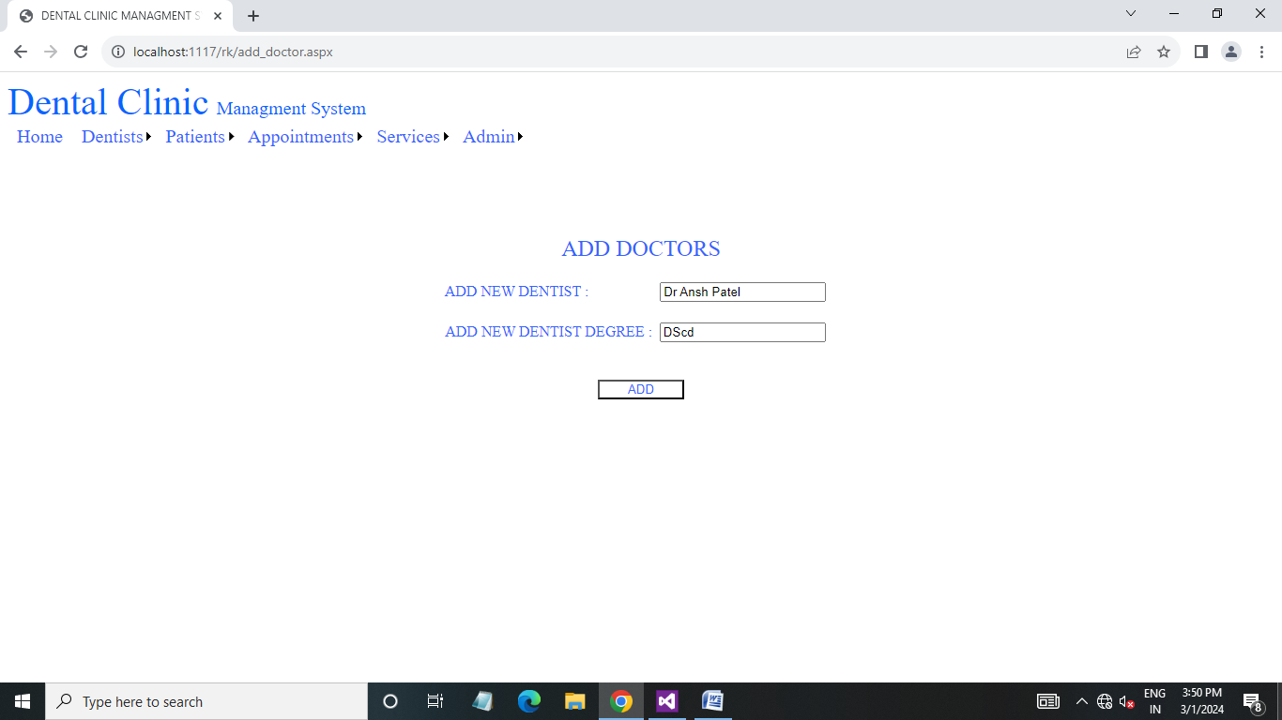

* This is example of fulfil proper data to add dentist.

Admin side dentist successful added page:

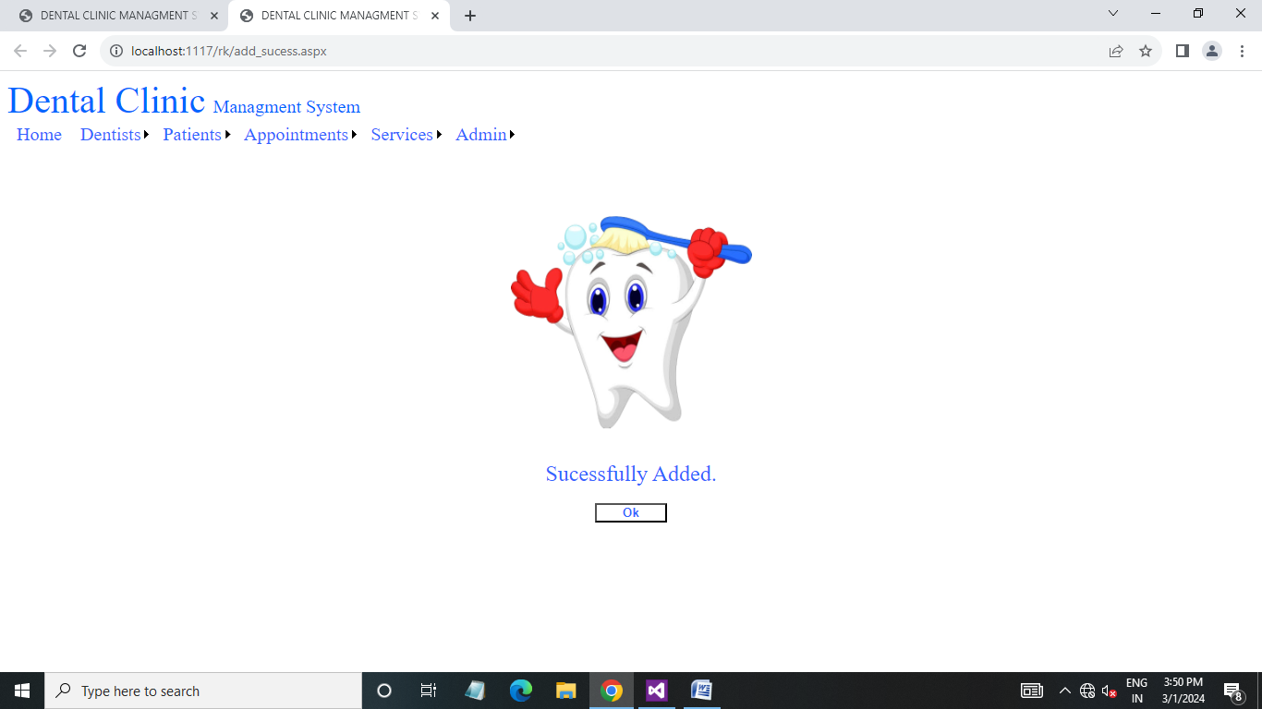

* This is dentist added success page .

Admin side all patient list page :

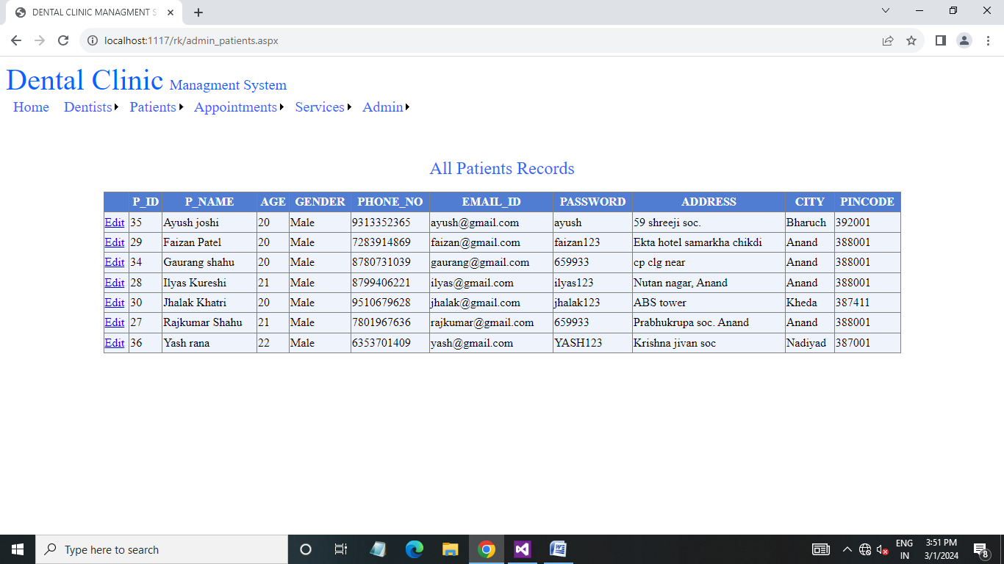

* In this page admin view all patient list and admin also edit details.

Admin side find patient page :

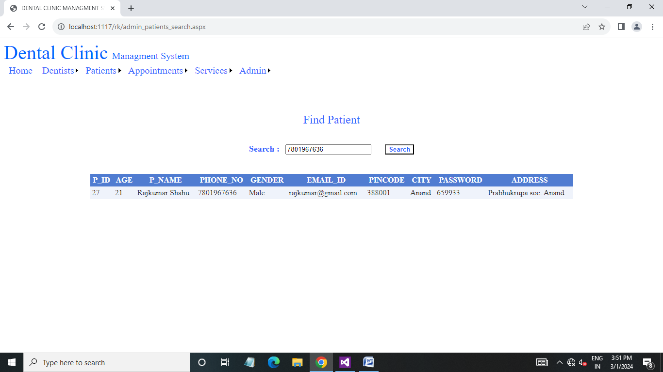

* In this page admin view patient details when admin insert patient mobile number.

Admin side all appointment list page :

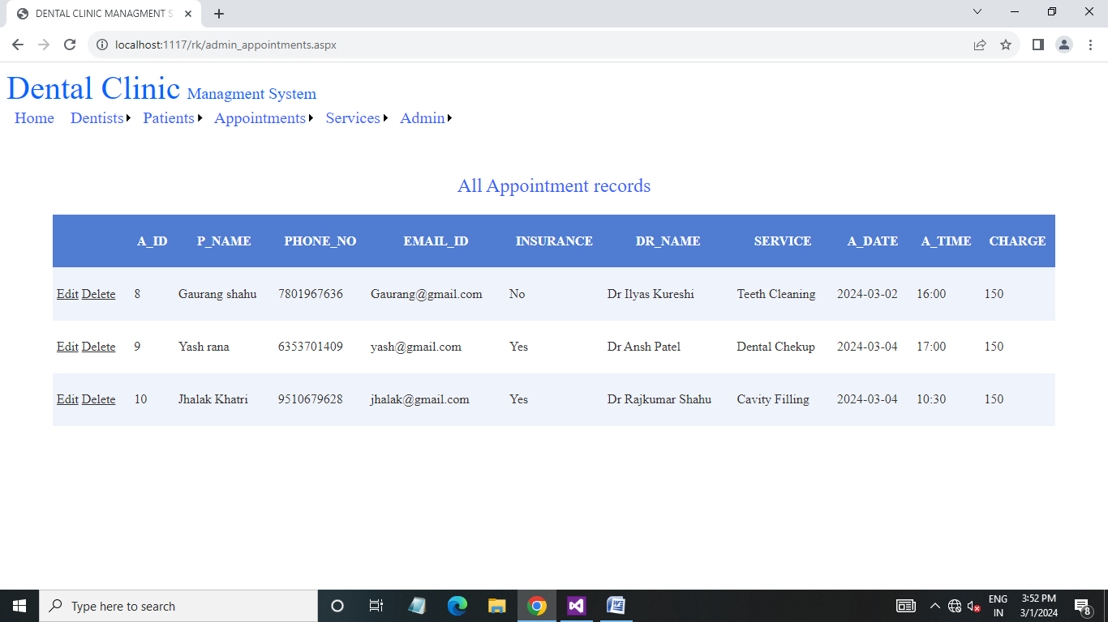

* In this page admin view all appointment list and admin also edit details and delete appointment data.

Admin side find appointment page :

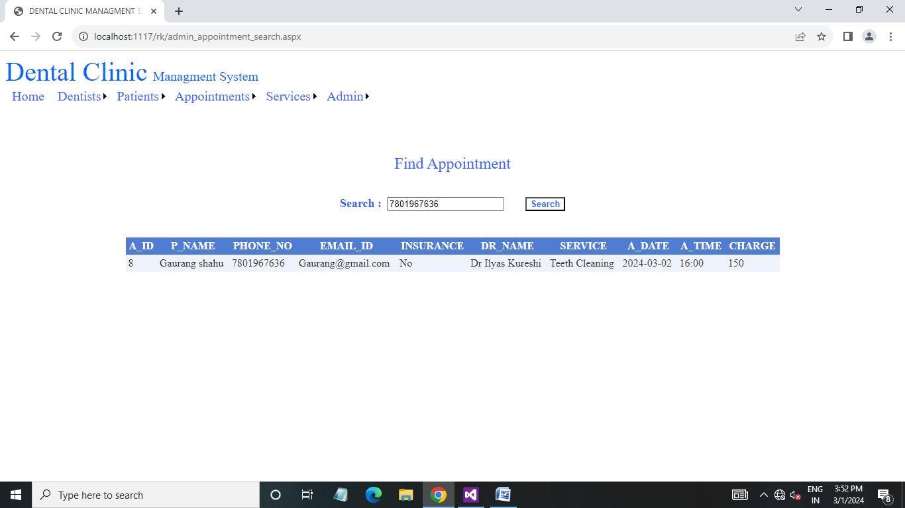

* In this page admin view all booked appointment when admin insert patient mobile number.

Admin side services list page :

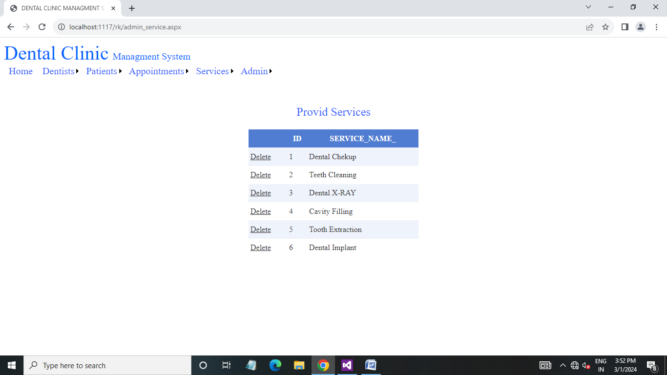

* In this page admin view all provided services and admin also delete services.

Admin side service add page :

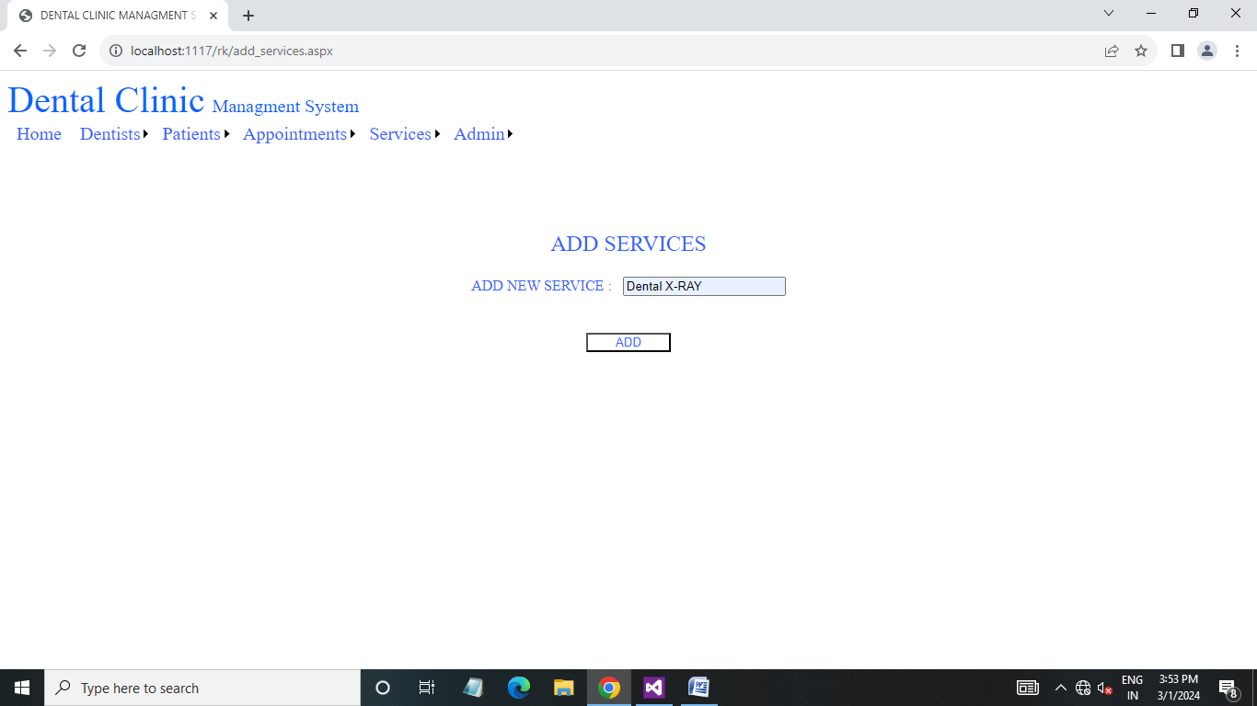

* In this page admin add new services.

Admin side service successful added page :



* This is service added success page .

Admin side admin list page :

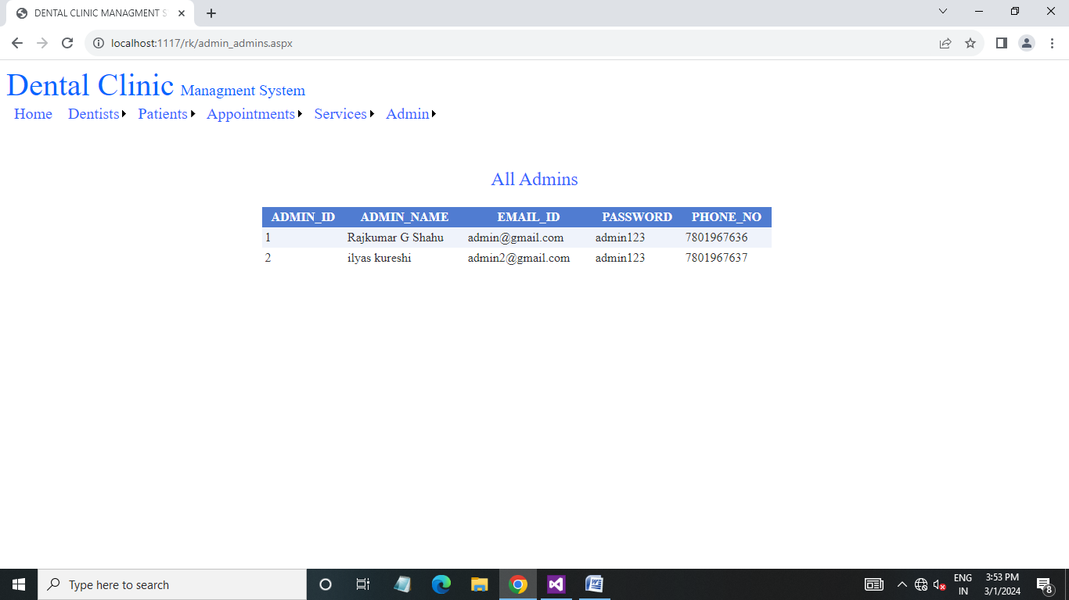

* In this page admin view all admins.

Admin side add admin page :

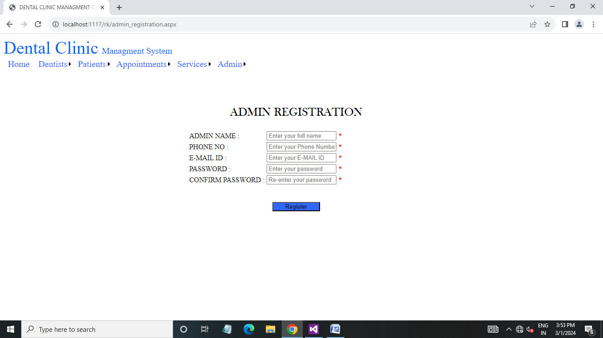

* In this page admin add new admin.

Limitation

Excel export has not been developed for dental clinic, doctor duo to some critically.

The transaction are executed in offline mode, hence online data for patient, text capture is not possible.

Offline reports of dental clinic, appointment, patient cannot be generated due to execution.

The user is provided help at each step for his convenience in working with the software punctuality of time was also major constraint thus it was not possible to make the software full proof and dynamic.

Proposed enhancement

The developed system is client server application it can be ported on the web in the later stages of development.

The dental clinic system currently runs on the windows platform only. In the future enhancement the system can be ported on the other platforms.

Conclusion

Our project is only a humble venture to satisfy the needs to manager their project work. The objective of software planning i9s to provide a frame work that enables the manager to make reasonable estimates made within a limited time frame at the beginning of the software project and should be updated regularly as the project progresses.



**Clean Teeth, Strong Teeth  
Thank You**

Created by : Mr. Rajkumar G Shahu